Software Requirements Specification

for

PAWCARE

Version 1.0 approved

Prepared by Birendra Bahadur Budha

AND

LUJANG SANTO LUPAI

RK University

2023-09-19

Table of Contents

Table of Contents ii

Revision History ii

1. Introduction 1

1.1 Purpose 1

1.2 Document Conventions 1

1.3 Intended Audience and Reading Suggestions 1

1.4 Project Scope 1

1.5 References 1

2. Overall Description 2

2.1 Product Perspective 2

2.2 Product Features 2

2.3 User Classes and Characteristics 2

2.4 Operating Environment 2

2.5 Design and Implementation Constraints 2

2.6 User Documentation 2

2.7 Assumptions and Dependencies 3

3. System Features 3

3.1 System Feature 1 3

3.2 System Feature 2 (and so on) 4

4. External Interface Requirements 4

4.1 User Interfaces 4

4.2 Hardware Interfaces 4

4.3 Software Interfaces 4

4.4 Communications Interfaces 4

5. Other Nonfunctional Requirements 5

5.1 Performance Requirements 5

5.2 Safety Requirements 5

5.3 Security Requirements 5

5.4 Software Quality Attributes 5

6. Other Requirements 5

Appendix A: Glossary 5

Appendix B: Analysis Models 6

Appendix C: Issues List 6

Revision History

|  |  |  |  |
| --- | --- | --- | --- |
| **Name** | **Date** | **Reason For Changes** | **Version** |
| Initial Release | 2023-10-29 | Initial release of the software requirements for the PAWCARE APP. | 1.0 |
|  |  |  |  |

# Introduction

## Purpose

A complete pet care solution, the Pawcare App, version 1.0, streamlines the administration of a pet's health and well-being. Its main objective is to streamline the scheduling of veterinary visits, allowing users to schedule consultations and get fast medical advice. For efficient connection with pet care specialists, the app also provides a smooth messaging platform. Users also have access to a handy immunization appointment scheduler. By offering a simple interface for ordering and reserving pet food, the Pawcare App expands its utility beyond healthcare. The functional and non-functional requirements specified in this Software Requirements Specification (SRS) are necessary to provide these essential services inside the Pawcare ecosystem.

## Document Conventions

This document follows a standardized set of conventions to ensure clarity and consistency in expressing requirements. "Must" indicates mandatory requirements that are essential for the system's core functionality. "Should" represents preferred, yet non-mandatory, features that enhance the user experience. "May" suggests optional features that could be considered for future iterations of the application.

## Intended Audience and Reading Suggestions

Developers, quality assurance specialists, project managers, and other important participants in the creation and rollout of the PAWCARE App are the document's main target audience. To completely understand the contents of this document, it is advised that readers have a fundamental knowledge of software development principles, Firebase, and project management ideas.

## Project Scope

The PAWCARE APP is a cutting-edge mobile app created to transform pet care administration. By providing features like appointment scheduling, keeping of veterinary records, and easy connection with pet care providers, it aims to simplify the experience of pet owners. This program attempts to increase customer convenience while improving the effectiveness of pet care services. The PAWCARE APP aspires to position itself as the top option in the pet care sector by coordinating with corporate goals and fostering client satisfaction, operational effectiveness, and long-term company success. Consult the supplementary document presenting the long-term strategic product vision for a complete vision and scope.

## References

This section gathers relevant outside resources important to the creation of the PAWCARE APP. It includes information on the Flutter framework, Firebase integration, and efficient project management methods. These references act as helpful informational resources, assisting programmers in the smooth integration of features, assuring the best possible use of the technology stack, and adhering to effective project management practices. By pooling these resources, the team is better able to traverse the development process, take advantage of Firebase's capabilities, tap into Flutter's potential, and apply project management best practices for a successful release of the PAWCARE APP.

# Overall Description

## Product Perspective

The PAWCARE APP is a pioneering, self-contained system designed to revolutionize the management of pet care. Unlike any existing platforms, it stands as a unique, independent product, tailored exclusively for pet owners and care providers. Offering functionalities such as appointment scheduling, direct messaging with veterinarians, and the convenience of ordering pet food, it caters to every facet of pet care. This comprehensive suite of features operates seamlessly within the app, minimizing dependencies on external systems. To enhance comprehension of the system's structure and interactions, a visual diagram will be provided. This schematic will delineate the major components, their interconnections, and the external interfaces, offering stakeholders a clear overview of the system's architecture. In essence, the PAWCARE APP is poised to redefine the pet care experience by amalgamating convenience, communication, and vital pet-related services into a single, user-friendly platform. Its standalone nature ensures that it operates autonomously, providing a reliable and efficient tool for both pet owners and care providers alike.

## Product Features

A number of important features included in the PAWCARE APP streamline and improve the pet care process:

### Appointment Scheduling

* Allows customers to easily schedule and manage appointments with vets or other pet care professionals.

### Food Ordering for Pets

* Allows customers to browse and order pet food, providing a smooth and timely supply of necessary hydration.

### Messaging with Veterinarians

* Facilitates real-time communication between pet owners and veterinarians for quick advice or consultation.

### User Profiles and Preferences

* Allows users to create and manage personalized profiles with details about their pets, preferences, and contact information.

## User Classes and Characteristics

The PAWCARE APP is designed to cater to a diverse range of user classes, each with distinct characteristics and requirements:

### Pet Owners

* Frequency of Use: Regular, often daily
* Product Functions: All features (Appointment Scheduling, Veterinary Record Tracking, Food Ordering, Messaging, etc.)
* Technical Expertise: Varied, from basic to advanced.
* Security/Privilege Levels: Standard user privileges, access to own pet's data

### Veterinarians and Pet Care Providers

* Frequency of Use: Regular, primarily for appointment management and communication
* Product Functions: Appointment Scheduling, Messaging, Record Access
* Technical Expertise: Moderate to advanced, comfortable with digital interfaces.
* Security/Privilege Levels: Enhanced privileges for accessing patient records and providing professional advice.
* Educational Level/Experience: Professional training and experience in veterinary care

### Emergency Services

* Frequency of Use: Infrequent, during emergencies
* Technical Expertise: Basic, proficiency in using mobile applications.
* Security/Privilege Levels: Priority access to critical services and information

## Operating Environment

Operating Environment for PAWCARE APP:

### Hardware Platform

* Compatible with smartphones and tablets (iOS and Android)
* Minimum recommended specifications:
* Processor: 1.5 GHz dual-core or equivalent
* RAM: 2 GB
* Storage: 16 GB available space

### Operating Systems

* iOS 12 and above for Apple devices
* Android 8.0 (Oreo) and above for Android devices

### Additional Software Components

* Firebase SDK for database operations and messaging services.

### Browsers

* Web browsers such as Google Chrome, Firefox, and Safari.

## Design and Implementation Constraints

* Front-end development is executed using the Flutter framework, ensuring a responsive and consistent user experience across both web and mobile platforms.
* Firebase serves as the backend platform, providing real-time database functionality, robust authentication, and cloud-based storage.
* Security is a paramount concern, necessitating the implementation of stringent measures, including user authentication and data encryption.

## User Documentation

Comprehensive user manuals and tutorials will be thoughtfully curated and provided alongside the PAWCARE APP, ensuring users can effortlessly navigate and harness their full potential. These resources are meticulously designed to empower customers, regardless of their technical proficiency, enabling them to make the most of the application's diverse features with a minimal learning curve. The user manuals will offer step-by-step instructions, accompanied by clear visuals and concise explanations, facilitating a seamless onboarding experience. Additionally, video tutorials will be available for a dynamic and interactive learning process. This commitment to robust user documentation reflects our dedication to user satisfaction and ensures that every individual can confidently utilize the PAWCARE APP to optimize their pet care experience. With these accessible resources at their disposal, customers can confidently explore and engage with the app's functionalities, making pet care management an intuitive and enjoyable process.

## Assumptions and Dependencies

* Assumptions are predicated on the assumption of basic user computer literacy, ensuring that users can interact with the system effectively.
* Dependencies encompass Firebase services for authentication, real-time database functionality, cloud-based storage, and cloud messaging for notifications. These services are central to the application's core functionality and are expected to function seamlessly.

# System Features

The system features for this project are given below:

## System Feature

The System Features for PAWCARE App:

### User Profile Management

* **Description**: Allows users to create, edit, and manage their profiles, providing essential information about their pets, preferences, and contact details.
* **Priority**: Medium

### Appointment Scheduling

* **Description**: Enables users to schedule and manage appointments with veterinarians or pet care providers.
* **Priority**: High

### Veterinary Record Tracking

* **Description**: Provides a centralized repository for storing and accessing pet health records, vaccinations, and medical history.
* **Priority**: High

### Food Ordering for Pets

* **Description**: Allows users to browse and order pet food, ensuring a seamless and timely supply of essential nourishment.
* **Priority**: Medium

### Direct Messaging with Veterinarians

* **Description**: Facilitates real-time communication between pet owners and veterinarians for quick advice or consultation.
* **Priority**: High

# External Interface Requirements

## User Interfaces

User interface requirements for an Pawcare app are essential for creating an intuitive and visually appealing platform that enhances the user experience. Here are some key user interface requirements:

### Responsive Design

### *The app must have a responsive design that adapts to various screen sizes and orientations, ensuring usability on smartphones and tablets.*

### Intuitive Navigation

* The navigation menu should be easy to access and provide clear links to essential sections, such as product categories, cart, and user profile.

### User Profile

* User profiles should allow users to manage personal information, schedules, and carts.

## Hardware Interfaces

The PAWCARE APP will interface with various hardware components to provide a seamless user experience. The key aspects of the hardware interface:

### Supported Device Types

* The app will be compatible with both iOS and Android devices, including smartphones and tablets, ensuring a wide range of user accessibility.

### Nature of Data and control Interactions:

* **Touchscreen Interaction**: Users will interact with the app primarily through touch gestures on the device screen.
* **Camera Access (Optional):** If enabled, the app may utilize the device's camera for functionalities like capturing pet images for profiles or uploading pictures.

### Communication Protocols

* **Internet Connectivity**: The app will require an active internet connection for functionalities such as appointment scheduling, messaging, and accessing external resources.

## Software Interfaces

The PAWCARE APP will integrate with Firebase, a comprehensive mobile and web application development platform. Here are the key aspects of the software interface:

### Database Management System

* **Name**: Firebase Realtime Database
* **Purpose:** This component will manage and store user profiles, appointment data, pet records, and other relevant information in real-time.

### Authentication and Authorization Services:

* **Name**: Firebase Authentication
* **Purpose**: Firebase Authentication will handle user login, registration, and management of user credentials securely.

### Realtime Database API Protocols

* Firebase Realtime Database offers API protocols for read and write operations, as well as real-time synchronization of data across clients.

## Communications Interfaces

* External APIs may be integrated for email notifications, providing an additional communication channel for project-related updates and notifications.

# Other Nonfunctional Requirements

## Performance Requirements

* **Must**: The application must exhibit responsive behavior, with user interactions yielding responses within a one-second time frame.
* **Must**: The system should be designed to handle concurrent users efficiently, supporting up to 1000 simultaneous users without compromising performance.

## Safety Requirements

* **Must**: User data, including sensitive information, must be securely stored and encrypted to safeguard user privacy and protect against data breaches.

## Security Requirements

* **Must**: The application must implement Firebase Authentication to ensure secure user authentication and access control.
* **Must**: Firebase security rules must be configured to restrict unauthorized data access and maintain data integrity.
* **Must**: Regular security audits and updates must be conducted to proactively identify and address potential security vulnerabilities.

## Software Quality Attributes

Software quality attributes, often referred to as non-functional requirements, are crucial for ensuring the overall performance, reliability, and user experience of an PAWCARE app. Here are some key software quality attributes for an PAWCARE app:

### Usability

* The app should have an intuitive user interface that is easy to navigate
* Ensure that users can easily find products, add them to the cart, and complete purchases without confusion.

### Performance Efficiency

* *Page load times and response times should be fast to provide a responsive user experience.*
* *Optimize resource utilization to ensure the app operates efficiently, even during peak traffic.*

### Reliability

* *The app should be highly reliable and available, with minimal downtime or service interruptions.*
* *Implement fault tolerance mechanisms to handle unexpected failures gracefully.*

### Scalability

* *Design the app to scale horizontally to accommodate growing user loads.*
* *Scalability should apply to both web and mobile versions of the app.*

### Security

* *Prioritize data security and user privacy through encryption, secure authentication,*

*and authorization mechanisms.*

* *Regularly update and patch the app to address security vulnerabilities.*

### Maintainability

* *Ensure that the app's codebase is well-organized and follows coding best practices.*
* *Provide clear documentation for developers to facilitate ongoing maintenance and*

*updates.*

### Compatibility

* *The app should be compatible with a wide range of devices, browsers, and operating systems to reach a broad user base.*

# Other Requirements

In addition to functional, performance, safety, security, and software quality requirements, there are other miscellaneous requirements and considerations for an Pawcare app that can enhance its functionality and user experience. These requirements can vary based on the specific needs and goals of the app, but here are some common examples:

## User Support and Customer Service

* Provide a mechanism for users to contact customer support for assistance, inquiries, or issue resolution.
* Implement a chatbot or live chat feature for real-time customer assistance.

## Product Recommendations

* Use algorithms to provide personalized product recommendations based on user behavior and preferences.
* Suggest related products to increase cross-selling opportunities.

## Affiliate Marketing Integration

* Integrate with affiliate marketing platforms to track and reward affiliates for driving sales and referrals.

These miscellaneous requirements can add value to your PAWCARE app and enhance the overall user experience. The specific requirements you choose to implement will depend on your target audience, business model, and competitive landscape. It's essential to prioritize features that align with your app's objectives and customer expectations.

Appendix A: Glossary

Certainly, here is a glossary of common terms and concepts related to an PAWCARE

app:

1. **Responsive Design**: Designing the app to adapt to various screen sizes and devices, ensuring a consistent user experience on desktops, tablets, and smartphones.
2. **SEO (Search Engine Optimization):** Strategies and techniques to improve the app's visibility in search engine results, increasing organic traffic.
3. **User Profile**: A personal account that stores user information, order history, and preferences within the app.
4. **Inventory Management**: The process of tracking and managing the availability of products in the app, including stock levels and restocking.
5. Shopping Cart: A virtual cart that users can add products to while browsing the app, allowing them to review and purchase multiple items in a single transaction.

Appendix B: Analysis Models

USECASE DIAGRAM:

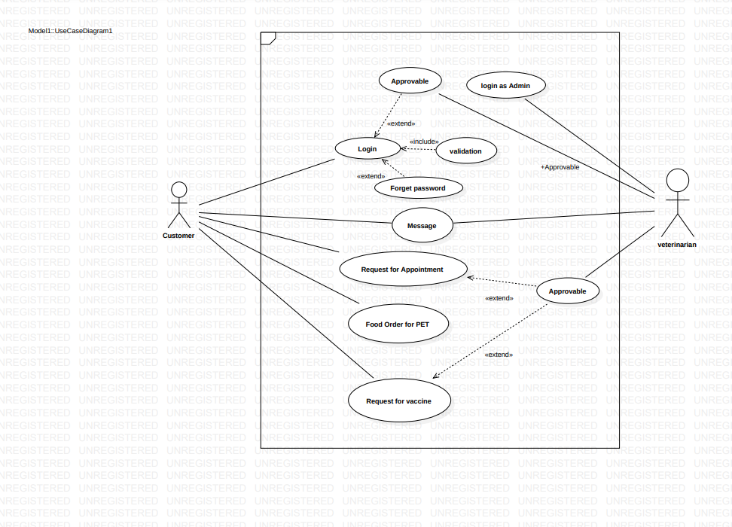

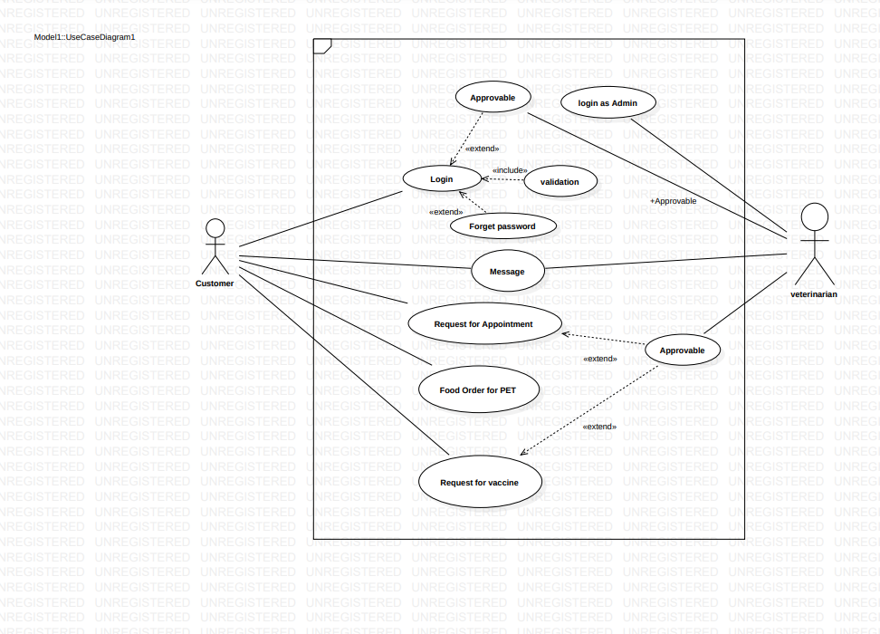

Appendix C: Issues List

An issues list for an PAWCARE app is a document used to track and manage various

problems, challenges, or tasks that need attention throughout the development and

maintenance phases. Here's a sample list of potential issues that might be relevant to

an PAWCARE app:

1. **Performance Bottlenecks**: Identify and resolve performance bottlenecks, such as slow page load times or high server resource usage.
2. **Security Vulnerabilities**: Regularly scan and address security vulnerabilities, including code vulnerabilities and server configurations.
3. **User Authentication and Authorization:** Review and enhance user authentication and authorization mechanisms to ensure security and ease of use.
4. **User Experience (UX) Enhancements**: Address user interface issues and usability challenges to improve the overall user experience.
5. **Data Synchronization**: Address data synchronization problems between the app and the database, ensuring data consistency.
6. **User Account Management**: Resolve issues related to user accounts, password resets, and account deactivation.

This list serves as a reference for tracking and addressing various issues that may arise during the lifecycle of an PAWCARE app. Prioritization, assignment of responsibilities, and regular updates are essential to effectively manage these issues and maintain a high-quality app.